EXERCISE-23

23.Design DFA using simulator to accept the string the end with ab over set {a,b)

W= aaabab

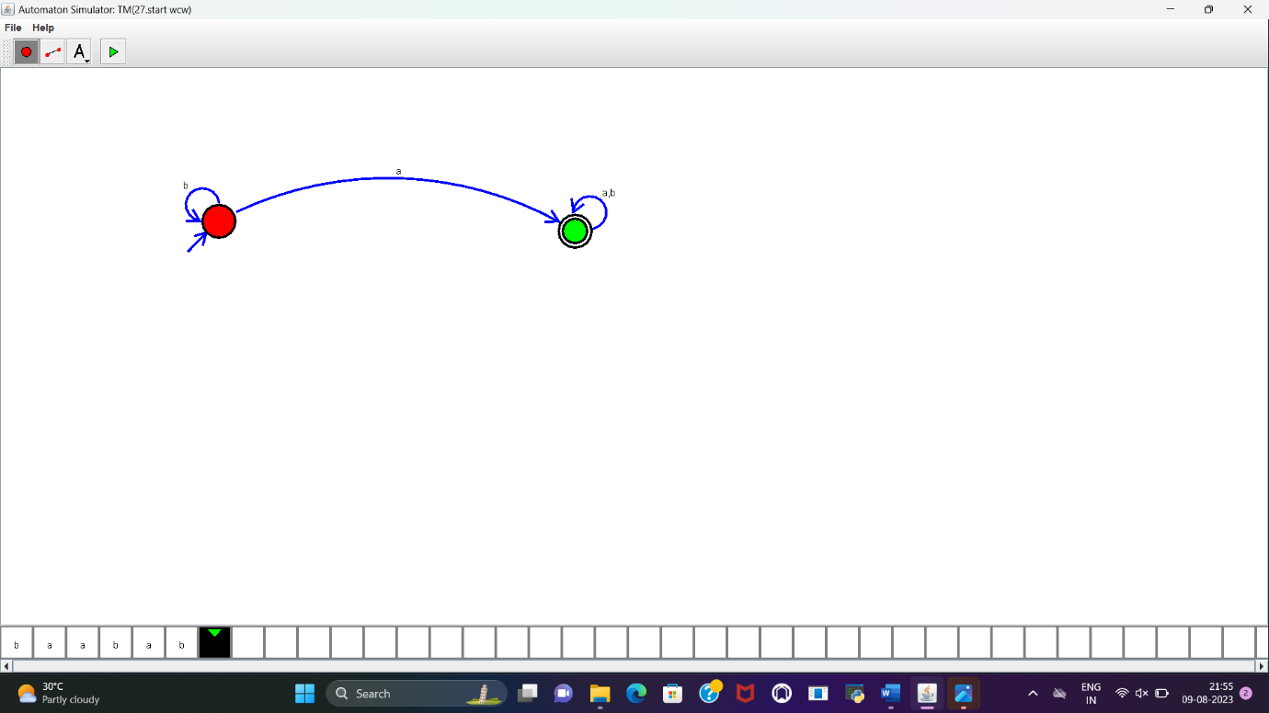

RESULT:

DFA to accept the string that end with “ab” over set {a,b} is designed and implemented successfully.